Lesson 19

‘For Each’ Syntax
In some programs, you may wish to do multiple operations to one type of control. Such an example might be the requirement to clear all the text boxes on a form. There is a variant of the “for next” loop which can go through every element within a group. The variant of the ‘for each’ variant of the ‘for loop’ allows access to all items in a collection.

For Each Syntax
The Syntax for the For Each statement is a follows:
For Each element In group
[statements]
[Exit For]
[statements]
Next [element]
The element is a variable that will be used in a similar manner to the variable of a counting ‘For Next’ loop. Each time around the loop the variable will reference a different item from the group. The variable can then be used to reference the item to either read or write property of the item. Each control will be one of the items in the group. The name used for group will be an array or object collection such as the list of controls in the form, which in the example is ‘Controls’.

The Appearance of the program
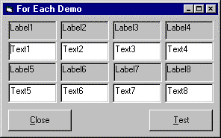
The program used to demonstrate the code needs a form that appears as the above. The text is still set to those set as the design properties value.

Example Code
The following code can be used to change the text on the textboxes and the caption on all the labels.
Option Explicit
Private Sub CommandClose_Click()
End
End Sub
Private Sub CommandTest_Click()
Dim num As Integer
Dim item As Control
For Each item In Controls
If TypeOf item Is TextBox Then
item.Text = "<" & Str(num) & ">"
End If
If TypeOf item Is Label Then
item.Caption = "<-" & Str(num) & "->"
End If
num = num + 1
Next
End Sub

Appearance after calling the code
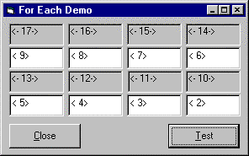
Note that the order in which the items are called includes in the two command buttons, which would are the items Number 0 and 1.

Modified Code to test for a particular control
When looping through the items it is possible to test for the name to exclude a particular item from the loop. In order to do this use the Name property to read the item name as the code below.
If TypeOf item Is TextBox Then
item.Text = "<" & Str(num) & ">"
If item.Name="Text2" Then item.Text="Is Text2"
End If

Exercise
Use the ‘For Each’ ‘Next’ code syntax to clear all the textboxes within an application.

